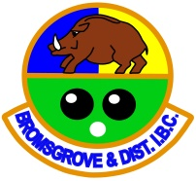
BROMSGROVE & DISTRICT INDOOR BOWLS CLUB – TEAM COMPETITIONS
MEN
Denny Cup (and Plate)
4 x Rinks – 2 x home and 2 x away
Over 60s Double Rink (2 teams)
2 x Rinks – 1 x home and 1 x away
Wessex League (2 teams – Bromsgrove & Bromsgrove Nomads)
4 x Rinks – 2 x home and 2 x away
LADIES
Yetton Trophy (and Plate)
4 x Rinks – 2 x home and 2 x away
Masons Trophy (Over 60s)
2 x Rinks – 1 x home and 1 x away
MIXED
Egham Trophy
4 x mxd rinks – 2 x home and 2 x away
Top Club
1 x mxd rink (2 men & 2 ladies)
1 x mxd triples (any combination)
1 x mxd pairs (1 man & 1 lady
1 x mens 2 wd singles
1 x ladies 2 wd singles

