Bromsgrove & District Bowls Club Ltd
Member Handbook
Incorporating

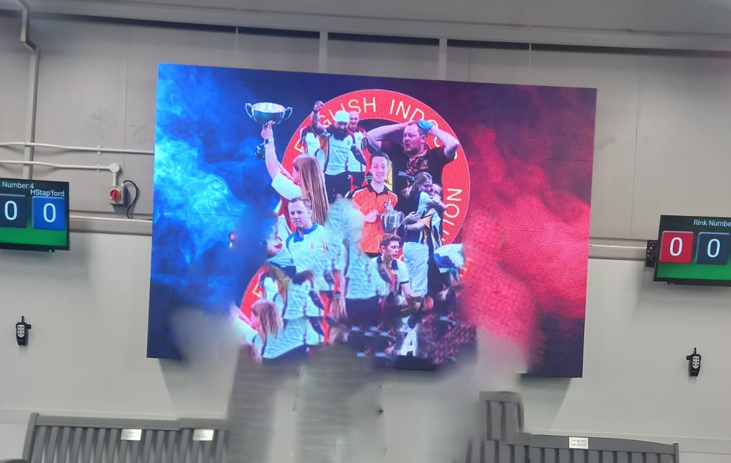

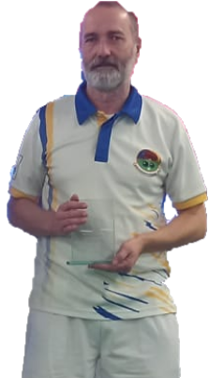

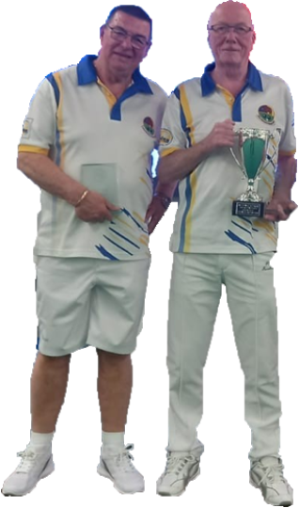

ENGLISH INDOOR BOWLING ASSOCIATION
National finals 2024/25 Over 60 runners up
Graham Arnold Peter Bryan Jim Collins Steve Morris

Version 6 Published NOV 2025
Foreword

Chairman of the Board

Welcome to Bromsgrove & District Indoor Bowls Club. The board’s aim is to maintain the facilities in good order for all members and visitors to play indoor bowls. If you are not happy about any aspect of the facilities, please speak with the duty steward, club manager or complete a suggestion form which will be recorded and brought to the board’s attention.

Ray Kellard

Chairman of the Management Committee

A warm welcome to Bromsgrove & District Indoor Bowls Club.

We try to provide you with a good mix of competitive and friendly bowling through our club leagues, competitions, friendly fixtures and competitive matches. Please support your captains by self-nominating for matches. Having too many nominations is a nice problem for them to have.
We are also proposing to run a number of social events throughout the season. It is your club, and your support and ideas are required to ensure these events are successful.
We are rightly proud of the club’s facilities but if you see or hear anything that is not quite right, please do let us know – we can only improve with your help.

Sue Atkinson

Table of Contents
1. Who are we?

2. What’s our purpose?

3 When are we open?

4. What do we offer?

5. Training for Umpires & Markers

6. What do we wear?

7. How do I become a member?
8. How do I find out what’s going on
9. Pre-season meeting

10. Website

11. Notice boards
12. Screen
13. How do I have a say?
14. Company Annual General Meeting

15. Interpretation

16. Membership
17. Membership cards
18. Members of the public
19. Affiliation

20. Bylaws

21. Alteration of bylaws

22. Bylaws of Bromsgrove Indoor Bowls Club

23. Management Committee
24. Club Annual General Meeting
25. Voting
26. Chair of meetings
27. Minutes
28. Sub-committees
29. Playing rules
30. General powers
31. Complaints and disciplinary procedures
32. Players code of conduct
33. Bar management
34. Use of the club & licensing restrictions
35. Firing shot
1. WHO ARE WE?
We are Bromsgrove & District Bowls Club Ltd, a company that runs Bromsgrove Indoor Bowls Club.

2. WHAT’S OUR PURPOSE?
We provide opportunities for playing indoor flat green bowls as well as coaching, playing, dining and social activities.
The facilities are also used by a range of groups other than those named above, currently Worcestershire County Indoor Bowling Association, Worcestershire Short Mat Association, and other external groups.

3. WHEN ARE WE OPEN?
All year round, but most indoor bowling is from the third week in September to the third week in April, from 09:30 - 22:00, week days. We are also open when bowling is scheduled at weekends.
In the summer months we operate reduced opening hours in line with the summer schedule of leagues and roll ups.

4. WHAT DO WE OFFER?
Coaching. Beginners are entitled to up to four 2 hour coaching sessions with a registered club coach free of charge – apart from the rink fee. If advanced coaching is required, this may incur a fee from the coach concerned.

Bowling. “Recreational bowling” (roll ups), for members and the public.

Improver sessions. On Tuesdays at noon and Thursday evenings for players who have attended coaching sessions, to provide experience of match play.

Sunday night. Bowls drives start at 6.15 – all invited, a good way to participate and improve your bowling skills and to meet bowlers who bowl in the weekday leagues.

League matches. Monday - Friday - for which you register before the season starts, or join a team already playing: Details can be found on the relevant notice board.

Details of winter leagues 2025/26
Day Time Format Time/ Ends
Monday 09.40 Rinks 2 Hours
Monday 12.00 Triples 2 Hours
Monday 14.20 Triples 2 Hours
Monday 16.40 Roll ups
Monday 19.00 Triples 14 Ends
Tuesday 09.40 Triples 2 Hours
Tuesday 12.00 Improver Session 2 Hours
Tuesday 14.20 Roll ups
Tuesday 16.40 Roll ups
Tuesday 19.00 Pairs 16 Ends
Wednesday 09.40 Triples 2 Hours
Wednesday 12.00 Triples 2 Hours
Wednesday 14.20 Over 70s League 2 sets
Wednesday 16.40 Roll ups
Wednesday 19.00 Triples 14 Ends
Thursday 09.40 Triples 2 Hours
Thursday 12.00 Triples 2 hours
Thursday 14.20 Roll ups
Thursday 16.40 Roll ups
Thursday 19.00 New Bowler League 2 hours
Friday 09.40 Triples 2 Hours
Friday 12.00 Triples 2 Hours
Friday 14.20 Presidents Cup Comp 2 Hours
Friday 16.40 Roll ups
Friday 19.00 Triples 14 Ends

Club friendly games. These are games played against other nearby clubs like Avon Valley, Birmingham and Welford, either at home or away. Members are encouraged to enter their names on the relevant sheets displayed on club notice boards – “nominating”. Teams for these matches are selected by the captains, and members who have nominated should check the notice boards to see if they have been selected to play. It is the responsibility of the selected players to advise the relevant captain by phone or in person if they become unavailable to play.

Club Championships. Competitions are arranged annually and members are encouraged to complete the entry forms (October each season) to enable them to participate. Some competitions are on pre-set dates and others need to be arranged by the participants. The application form makes it clear.

Wessex League. This is a league played on Sunday mornings and is for men. Members wishing to play should nominate on the relevant sheet. Team players for the Bromsgrove and Bromsgrove Nomads teams are selected by the relevant team managers.

National/County team Competitions. Nomination sheets will be posted on the notice board, team players will be requested to nominate and teams will be selected by the relevant team managers
- Denny Cup & Over 60 double rink (men)
- Yetton & Mason Trophies (ladies)
- Egham & Top Club (mixed)

Liberty This men’s competition is played at the highest level of competition within the county. Men may be invited, or nominate to represent Worcestershire County in the Liberty Trophy.

National/County Championships. Members are encouraged to enter these events which are played in a variety of formats. Players will play either at home or away, in each event entered, against players from other local clubs in the early rounds. If you are the home team it is important that you understand the rules regarding offering rink space to play your match. Entry forms will be posted by the office and must be completed by early April each season. Completed forms together with entry fees should be handed to the duty steward.

Other bowling events. These may be organised on an ad hoc basis throughout the year e.g. Ryder Cup, Christmas Triples, etc. and will be advertised accordingly.
Worcestershire County Indoor Bowling Association.
Worcestershire County Short Mat Bowling Association.
The above organisations also use our facility to play bowls matches. It may be possible to join these groups to increase your bowling experience. See their notice boards for contact details.

5. TRAINING FOR UMPIRES AND MARKERS
Markers’ and coaches’ courses can be run both ‘in house’ and externally – they will be advertised on the umpires’ noticeboard.

6. WHAT DO I WEAR?
Smooth soled shoes put on after entering the club and removed before leaving. When representing the club in friendly matches or national/county team events, we expect players to wear a Bromsgrove club shirt and black trousers/skirt/shorts. For most other play, we have adopted a relaxed dress code which allows players to choose what they wear.
We trust and encourage members to dress appropriately for taking part in a game of bowls. Photos of the club shirts follow.

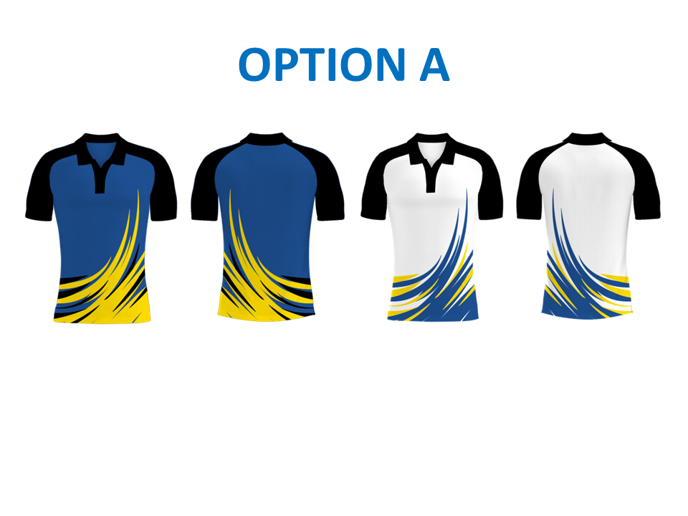

7. HOW DO I BECOME A MEMBER?
Obtain a membership application form from the office, complete and return it, and wait to hear about your application. It will be approved by members, management committee and directors.
8. HOW DO I FIND OUT WHAT’S GOING ON?
Stewards are on duty all day, every day, usually in the bar area or working in the club. Regular member emails are sent out to keep members up to date. See also below - pre-season meeting, website, noticeboard and screen.

9. PRE-SEASON MEETING AND CLUB AGM
This is held in the evening of the first Friday in September. This is a general look ahead to the new season and a more formal look back at the previous season. Announcements will be made from the management committee and finance director that may impact on the new indoor season.

10. WEBSITES
Our main club website will be found at www.bromsgroveibc.com Plenty of information relating to the club is available on the site. Up to date results and league tables can be found on our separate website at www.bibc2.com

11. NOTICE BOARDS
Information regarding leagues, friendly matches (club or county), national games, competitions (club or county), coaching notices will be found on the club’s notice boards.

12. SCREEN
The screen in the foyer shows current and relevant information for members from time to time.

13. HOW DO I HAVE A SAY?
Bowlers may complete and return a suggestion form on any issue they feel can be improved about the club or the bowling activities within or about the club. Completed forms should be posted in the suggestion box in the foyer. They are then considered by the board of directors or the management committee as appropriate.

14. THE COMPANY AGM
This is held at 10.00am on the first Saturday in December each year, which shareholders may attend. Members of the club may become shareholders of the company by buying a share (£25). An application form is available from the duty steward.

The Formal Bit

15. INTERPRETATION OF THE RULES
In these rules where the context so allows, words containing the male gender incorporate the female gender and words containing the singular number include the plural and vice versa.

16. MEMBERSHIP
Membership of the club shall be open to all persons who wish to participate in the game of indoor bowls whether as players or spectators but subject always to the Memorandum and Articles of Association of the limited company.

Membership is open to anyone not less than eight years of age, irrespective of age, disability, gender reassignment, marriage and civil partnership, pregnancy and maternity, race, religion or belief, sex, and sexual orientation and will comprise of ordinary, social, and junior members.
Nominations for membership shall be made to the company secretary on the form prescribed by the directors from time to time. Applicants for membership shall be proposed and seconded, and either or both proposer and seconder must be a playing member of the club. Application for membership must be accompanied by the payment of the relevant joining fee, and annual subscription.

The company secretary shall inform each candidate of the result of his application. He/she shall then be deemed to have agreed to be bound by the rules and bylaws of the club.

A member may resign his/her membership of the club by letter to the company secretary, but shall be liable for the subscriptions and fees for the year during which he/she resigns. All nominations for membership shall come up in date order of application. If a waiting list exists, priority shall be given to residents of the district.

Members paying the required fees shall be entitled to enjoy the benefits of organised play, matches and competitions as arranged.

Junior members shall enjoy the same benefits. Junior membership shall cease at 18 years of age.

Social members shall not be entitled to play on the green except as visitors. Social membership shall be limited to not more than 15% of the total membership.

Members and supporters of visiting teams competing at the club’s premises shall be deemed to have reciprocal membership for the period of the event limited in all to 60 persons.

Every member of the club shall, subject to the rules in force at the time, be entitled to enjoy in common with other members, the use of the club and its facilities.
A member shall inform the company secretary of any change of contact details within seven days. A register of names and addresses of all members of the club shall be kept on the club premises. All data is processed in line with the club’s GDPR Privacy Notice.

Honorary life membership may be conferred on any member on the recommendation of the board of directors and the relevant management committee.

The annual subscription, joining fee and any other fees payable shall be determined by the directors. Details of all such fees shall be posted prominently in the club premises and in addition, details of subscription fees shall be set out on the forms of application for membership. Membership fees are for a full twelve months of the year.

A person who becomes a member during any year commencing 1st October may, at the discretion of the directors, pay a proportion of the annual subscription for the current year.

Any member whose annual subscription remains unpaid as at 1st October immediately following the due date shall cease to be entitled to use the club facilities while the same remains unpaid and shall forfeit all rights in and claims upon the club and its property.

17. MEMBERSHIP CARDS
The club no longer issues membership cards

18. MEMBERS OF THE PUBLIC
We welcome members of the public to use the bowling facilities of the club. Such persons who have bona fide paid for the use of the bowling facility shall be entitled during that time to use the club. Members of the public may be allowed to play on the green upon payment of the appropriate charge.
19. AFFILIATION
Bromsgrove & District Indoor Bowls Club affiliates all its members to the English Indoor Bowling Association (EIBA). This enables them to enter and play in national team championships or represent the club in national team championships.

20. BYLAWS
The directors shall make any bylaws considered by them to be necessary in the best interest of the club and a copy of such bylaws shall be placed on the relevant notice board. Compliance with all bylaws shall be obligatory upon all members, guests and visitors.

21. ALTERATION TO THE BYLAWS
The board of directors has the powers to amend, delete or add to the bylaws, to take immediate effect provided that at least two thirds of the board is present and the majority vote in favour, thereof, but such amendment, deletion or addition shall be ratified at the next Annual General Meeting of the company.

22. BYLAWS OF BROMSGROVE INDOOR BOWLS CLUB
1. The care and maintenance of the green shall be the responsibility of the directors.
2. The club dress code for league, club and national matches can be found in item 6 of this booklet.
3. No smoking, eating, or drinking shall occur on or near the green. There are designated smoking areas outside the building and eating areas inside the building remote from the green. Members contravening this rule will be asked to refrain from so doing.
4. No harmful substance shall be used on bowls e.g. Grippo or glycerin or the like.
5. No notices are to be placed on the club notice boards without permission of the company secretary.
6. Bowls bags, clothing and all such equipment shall be kept in lockers or the changing rooms at all times.
7. Lighting, heating and ventilation shall be controlled by the duty steward following the instructions of the appointed director.
8. Members, guests and visitors may bring their own food into the premises for consumption on the premises, provided that food isn’t available for sale at the club.
9. No animals are allowed within the club premises except for assistance dogs.
10. Any child using the facilities must be under the supervision of a responsible adult at all times.
11. The company is not responsible for any loss or damage to members’, guests’ or visitors’ property at the club.
12. Leagues and competitions – please refer to the rules displayed on the appropriate notice boards.

23. MANAGEMENT COMMITTEE
1. The management committee is responsible for the organisation and administration of day-to-day matters appertaining to bowling and social activities within the club.
2. The management committee shall meet as often as required to carry out their duties effectively. A quorum shall be 5 officers/officials of whom 3 shall be officers of the club. This consists of:-

Officers of the club
President
Vice President
Chairperson
Club Secretary
Social Fund Treasurer
Leagues’ Secretary
Mens’ Captain
Ladies’ Captain

Officials of the club
Vice-Captains
Competitions’ Secretary
Ladies’ Team Manager
Bromsgrove Team Manager (Wessex & Mens National teams)
Bromsgrove Nomads’ Team Manager (Wessex League)
Fixtures’ Secretary
Coaching Co-Ordinator
Social Secretary
All committee members shall be elected pursuant to rule 24

24. CLUB ANNUAL GENERAL MEETING
1. An Annual General Meeting (A.G.M.) of the club shall be held not later than 30th September every year, for the purpose of: -
- Electing officers and officials.
- Considering any other relevant business.
2. Matters to be considered (under rule 12.2) must be received in writing by the management committee’s secretary not less than 14 days before the A.G.M.
3. A notice convening the Annual General Meeting shall be posted on the club notice boards not less than twenty-one days before the meeting and shall specify the matters to be dealt with. Matters to be raised under “other relevant business” shall be posted not less than seven days before the A.G.M.
4. The quorum at the A.G.M. shall be twenty members.
5. Candidates for election as officers and officials must be proposed and seconded by members of the club. Nomination notices must be displayed by the management committee secretary in the clubhouse for a period of not less than fourteen days before the A.G.M. and signed by the consenting nominee and duly countersigned by the proposer and seconder.
6. A vacancy occurring by serious illness or resignation of any officer or official may be filled by the committee appointing one of its number or some other member of the club to fill it until the next A.G.M.
7. An Extraordinary General Meeting (E.G.M.) may be convened at any time by the management committee and shall be convened within twenty-one days from the receipt of a request in writing signed by not less than thirty members specifying the object of the meeting. Details of the meeting including date and time shall be posted on the clubs notice board. No other business may be conducted at the meeting and twenty members shall form a quorum.

25. VOTING
Voting at a club general meeting or E.G.M shall be by a show of hands or otherwise as the chairman may direct. Postal or proxy votes are not acceptable for these meetings

26. CHAIR AT MEETINGS
The chairman of the management committee shall preside at all meetings of the club but if he is not present within fifteen minutes after the time appointed for the meeting or has signified his inability to be present, the members present shall choose one of their number to be chairman of the meeting. The chairman shall have a casting or additional vote in the event of an equality of votes.

27. MINUTES
The club secretary or his/her appointed deputy shall record the proceedings of the general and all committee meetings.

28. SUB-COMMITTEES
The management committee shall form all sub-committees as considered necessary and expedient. Any club member may be co-opted to serve on a sub-committee as considered appropriate except for a finance sub-committee, which must be composed of board members only.

29. PLAYING RULES
The playing rules shall be in accordance with the laws of the relevant affiliated authorities, with the exception that club leagues and club competitions will be governed by domestic rules. A copy of club league and competitions rules will be found on the relevant notice boards.

30. GENERAL POWERS
The committee shall have power, subject to any prevailing legislation to deal with all bowling matters relating to the club not provided for in these rules.

31. COMPLAINTS AND DISCIPLINARY PROCEDURES
The Club’s disciplinary procedure is available to view on the Club’s website in the ‘formal club documents’ tab.

32. CODE OF CONDUCT FOR CLUB MEMBERS
Bromsgrove & District Indoor Bowls Club is fully committed to safeguarding and promoting the well-being of all its members, ensuring a positive and enjoyable experience for all. A copy of the Club’s code of conduct is available to view on the Club’s website in the ‘formal club documents’ tab.

33. BAR MANAGEMENT
The club licensee shall be responsible for the purchase and sale of alcoholic liquor and other commodities associated with the bar. All accounts for bar merchandise shall be confirmed by the club licensee and passed to the finance director for payment.

34. USE OF THE CLUB AND LICENSING RESTRICTIONS
a). The club shall be entitled to sell or supply alcoholic liquors to the following persons (all of whom must be at least 18 years of age) namely:

i). Members and their guests.
ii). Members of visiting teams participating in a match or other competitions at the club premises.
iii). Visitors.

b). Subject to prevailing legislation the operating hours for the bar are Monday to Saturday 9am to 11pm such hours being subject to the discretion of the club licensee. Opening times on Sundays are subject to the licensee’s discretion, closing time to be 10pm.

c). GUESTS mean an individual person or persons invited to the club by a member.
VISITORS mean outside persons (not being members of a visiting team) visiting the Club otherwise than by invitation.
VISITING TEAM please note the total number of players per visiting team shall not at any one time exceed four players for each rink to be played upon in the relevant match or competition.
SOCIAL MEMBER shall mean a non-playing member.

35. FIRING SHOT
Any person intending to play a FIRING SHOT should advise the players on and off the green, especially on the adjacent rinks.
If any injury to an individual or damage to any club property is caused through the firing shot, then the player concerned could be held responsible.

Players at the other end of the green, and on adjacent rinks, should also take action. They are encouraged to ensure all players safety by:
- Warning players on adjoining rinks
- Informing the gallery of non-players watching the game from the seating area
- Assessing the head, standing on each side of the rink, usually but not always in front of the jack, to protect yourselves and players on adjacent rinks

We hope you have found this document useful; if it doesn’t have all the information you need then please ask a steward, management committee member or director (photos in the entrance hall) or indeed any other club member – we are all happy to help.

Issued jointly by the company board and the management
committee
Notes:

